Sprint 3 – Agility Design Document

December 3, 2020

Table of Contents
1. Executive Summary 3
1.1 Project Overview 3
1.2 Purpose and Scope of this Specification 3
2. Product/Service Description 3
2.1 Product Context 3
2.2 User Characteristics 3
2.3 Assumptions 3
2.4 Constraints 3
2.5 Dependencies 4
3. Requirements 4
3.1 Functional Requirements 5
3.2 Security 5
3.2.1 Protection 5
3.2.2 Authorization and Authentication 6
3.3 Portability 6
4. Requirements Confirmation/Stakeholder sign-off 6
5. System Design 6
5.1 Algorithm 6
5.2 System Flow 6
5.3 Software 6
5.4 Hardware 6
5.5 Test Plan 7
5.6 Task List/Gantt Chart 7
5.7 Staffing Plan 7

Executive Summary

Project Overview
The main objective of this project is to successfully problem solve, quantify, organize, document, code, test, and present a software system. The intended robot project will be completed with clear instructions for the following performance tests: Endurance, Accuracy, and Agility. Sprint 3 will be focusing on Agility.

Purpose and Scope of this Specification

The purpose of this specification is to allow children, adults, students, and professors to use the robot in its intended conditions (smooth and flat surfaces). This robot can be used for educational purposes as well as just playing around the house. In this sprint, we will be focusing on the accuracy of the robot and its program. This will be tested through a figure eight course.

In scope
- The robot and its program is intended for inside use only
- The robot and its program requires a smooth flat surface
- The robot and its program requires large enough space to successfully run the program

Out of Scope
- The robot and its program is not intended to be used on rough or bumpy surfaces
- Operating on these surfaces can result in damage to the robot.
- Outside elements can also cause damage to the robot and could cause it to not run properly

Product/Service Description

Product Context
This is the third and final test of the Robotics Triathlon project which is the agility test.

User Characteristics
Users of this robot may consist of students, faculty, staff, individuals with previous coding experience or technical expertise. In order to use the robot, users simply need to understand simple block coding via the Sphero App. Access to a device with Bluetooth is required in order to successfully connect to the robot via the Sphero App.

Assumptions
- The robot and its program will only work on certain operating systems
- iOS, Android, Fire OS, Windows, Chrome, and macOS
- Access to a flat, indoor surface that was able to meet the required measurements

Constraints
- Not all members had access to the robot
- COVID-19 limited our opportunities to meet in person
- Some members of the group work full time/part time jobs
- Members weren’t able to use room with official measurements on campus

Dependencies
- Robot must follow the correct path
- This project is dependent on that robot following the correct path
- If not, it will not succeed the intended goal/path
- Code must be established
- SpheroSPRK+ must be charged every hour

Requirements

Functional Requirements
Req# | Requirement | Comments | Priority | Date Rvwd | SME Reviewed / Approved
AGILI_05 | Robot must avoid the 3 objects. | Making sure robot does not run into any of the obstacles. | 1 | 11/25/20 | Approved
AGILI_05 | Robot should knock over the pins. | Robot should knock over as many pins as possible making sure that there are no pins left behind. | 1 | 11/25/20 | Approved
AGILI_05 | Robot should stay withing the path. | It should not go outside of the path and stay withing. | 1 | 11/25/20 | Approved
AGILI_05 | It should be able to go over the ramp. | Making sure the robot degrees correlate with the ramp | 2 | 11/25/20 | Approved
AGILI_05 | The coding should have precise seconds and degrees. | Making sure the robot does not go too far and goes on a steady route. | 2 | 11/25/20 | Approved
AGILI_05 | Robot should complete the square. | Making sure it finishes the whole square before going onto the ramp. | 3 | 11/25/20 | Approved
AGILI_05 | The robot should have clear directions | The coding should not be all over the place where the robot does activities it is not supposed to. | 3 | 11/25/20 | Approved

Security

Protection
-Code will be developed in the app Sphero.Edu and it will be listed as private

- Code is private and shared only among the people within the group, their accounts are on private as well

-To access GitHub with the files of our project, only people with the link will have the access.

-The only ones with the link are the professor and the group. The group is the only one who is allowed to add, delete, review files because the collaborator has invited them and only them to access.

Authorization and Authentication
- only person who is allowed to view and/or access the coding is the one who has the Sphero.Edu username and password.

-This account is strictly for coding group projects in which the coding is listed private and no one can view it accept the ones who are given access.

-When it comes to GitHub, the collaborator has to invite others to edit, view, and add files. The only people given invitation are the members within the group.

Portability
- One member has access to the code which is made on Spehor.Edu but the member has shared the coding among the individuals
- 60 Percentage of code is being done by one member while the other member does 40 percent. When developing the code, the partners work together to figure it out.

Requirements Confirmation/Stakeholder sign-off

Meeting Date | Attendees (name and role) | Comments
11/25/2020 | Michael Auletto: Develop Code, Test Code  Jamir Barnes: Complete second part Design Doc  Christian Dimitry: Complete first part Design Doc  Haemah Akhtar: Complete last part Design Doc | Task were given out to each member with the due date on when to be specifically done.

System Design

Algorithm
Develop and describe here the algorithm that will be used to provide the required performance of your software

- Turn Sphero on by either shaking or double tapping
- Connect the Sphero to the app Sphero.Edu through Bluetooth to a computer
- Sphero will be put on the ground at the starting point
- Roll 0 degrees at speed 40 for 2.8 seconds
- Roll 90 degrees at speed 40 for 2.4 seconds
- Roll 0 degrees at speed 40 for 2.2 seconds
- Roll 141 degrees at 85 speed for 4.5 seconds
- Stop robot
- Exit program

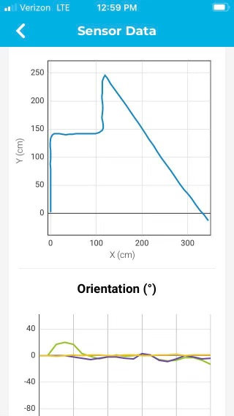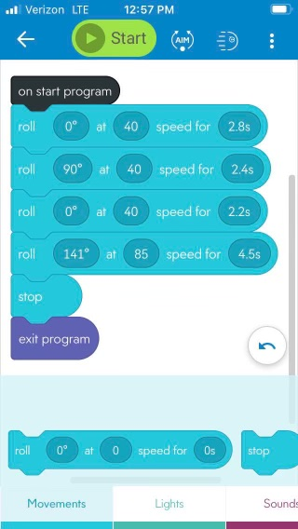

System Flow
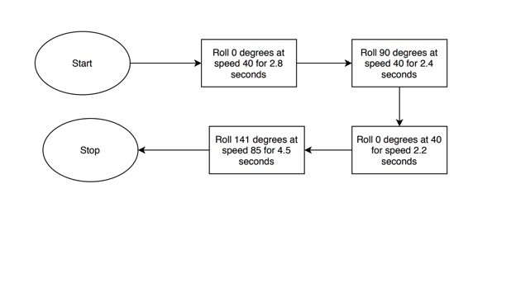

Software
- The app Sphero.Edu that has been downloaded computers (MacBook and Windows
-Sphero.Edu has JavaScript which is being used, there is block coding occurring to develop a program for the robot.

-To test the block code on the robot, Bluetooth is able to connect the devices.

Hardware
-The Hardware being used is the computer (MacBook and Windows Desktop) and an Apple iPhone 11.

-The computer and iPhone allow one to develop the coding on the app.

-The coding is tested on the robot which will be connected through Bluetooth which will connect the robot to the computer or iPhone depending on which one the partner chooses.

Test Plan

Reason for Test Case | Test Date | Expected Output | Observed Output | Staff Name | Pass/Fail
Robot is able to finish the square. | 11/30/20 | Robot should run through the square avoiding obstacles. | Robot was able to run through the square without any issues. | Michael Auletto | Pass
Robot speed and degrees should be able to match. | 11/30/20 | Robot should finish off with degrees and speed that match the. | Robot is able to stay on the path. | Michael Auletto, Haemah Akhtar | Pass
Robot should avoid the obstacles. | 11/30/20 | Robot should complete the course without running into any obstacles. | Robot was able to complete the square without any issues. | Michael Auletto | Pass
Robot should go over the ramp. | 11/30/20 | It should go over the ramp without any issues. | Robot went over the ramp without any issues. | Michael Auletto | Pass
Robot should proceed with course getting ready to hit the obstacles. | 11/30/20 | Making sure robot is ready before running through the pins. | Robot is prepared before running through the pins. | Michael Auletto, Haemah Akhtar | Pass
Robot hits the pins | 11/30/20 | Robot should hit all the pins. | Robot goes too fast pins knock down but 2 remain. | Michael Auletto | Fail
Robot hits all the pins | 11/30/20 | Making sure robot does not miss a pin. | Robot hits all of the pins. | Michael Auletto,  Haemah Akhtar | pass

Task List/Gantt Chart
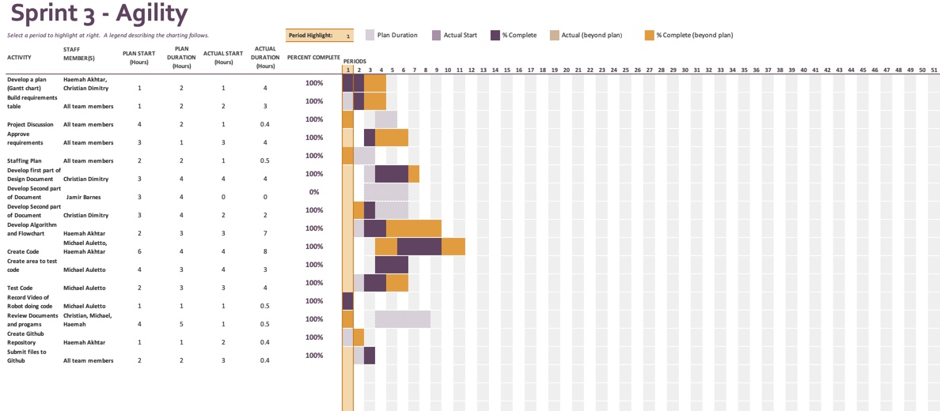

Staffing Plan

Name | Role | Responsibility | Reports To
Jamir Barnes | Develop Document | Develop second part of the document, review document when finished | Haemah Akhtar
Christian Dimitry | Develop Document | Develop first part of the document, review document when finished, help out with Grantt Chart | Haemah Akhtar
Michael Auletto | Code Development | Create Obstacle course, create test code, and test the code | Haemah Akhtar
Haemah Akhtar | Develop Document,  Leader of Group, | Develop Last part of document, help with code development, provide tasks for group | Haemah Akhtar

